## New Member Orientation

Member ID: ___________________________ Loyalty Order date: __________________________

* Review products & answer questions

|  |  |  |
| --- | --- | --- |
| **Retail** | **Wholesale** | **Below Wholesale** |
| Full price | 25% off | 25% off |
|  |  | Loyalty Rewards Additional discount  Lifelong Vitality Pack + up to 3 discounted items below wholesale |
|  |  | Up to 30% back FREE product points  100% FREE Shipping points |
|  |  | Participate FREE product of the month |

### Example Orders

125PV order before 15th Month. US Prices.

|  |  |  |  |
| --- | --- | --- | --- |
|  | **Retail** | **Wholesale** | **Below Wholesale** |
| Lifelong Vitality Pack | $106 | $79.50 | $79.50 |
| TerraZyme | $50 | $37.50 | $20 |
| Mito2Max | $52.67 | $37.50 | $20 |
| Peppermint 15ml | $29.33 | $22 | $22 |
| Lavender 15 ml | $30.67 | $23 | $23 |
| **SHIPPING** | $3.99 | $3.99 | $3.99 |
| POINTS EARNED | 0 | 0 | **41.5 (30%)** |
| FREE product of the month | N/A | N/A | **FREE ($20 Value)** |
| **Total** | **$272.66** | **$203.49** | **$164.50** |
| Savings | 0 | $69.17 | $128.16 |

|  |  |  |  |  |  |
| --- | --- | --- | --- | --- | --- |
| **Loyalty Rewards Order Personal Volume (PV)** | **1+** | **50** | **100** | **125** | **200** |
| Maintain Loyalty Rewards Points | Checkmark | Checkmark | Checkmark | Checkmark | Checkmark |
| Earn Loyalty Rewards Points & Increase percentage |  | Checkmark | Checkmark | Checkmark | Checkmark |
| Earn Commissions |  |  | Checkmark | Checkmark | Checkmark |
| Free Product of the Month benefits (order by 15th) |  |  |  | Checkmark | Checkmark |
| Free product promotion |  |  |  |  | Checkmark |

|  |  |  |  |  |
| --- | --- | --- | --- | --- |
| 25% Wholesale Discount | | | | |
| Percentage Back in Product Credits | | | | |
| 10%  Months 1-3 | 15%  Months 4-6 | 20%  Months 7-9 | 25%  Months 10-12 | 30%  Months 13+ |
| Total Savings & Credits | | | | |
| 35% | 40% | 45% | 50% | 55% |

|  |  |
| --- | --- |
| **Wholesale Customer** | **Wellness Advocate** |
| * Product discounts * Loyalty Reward Points (LRP) * Shipping Rewards * Free Product of month * $25 annual renewal fee (Get a free 15ml Peppermint oil $27.33 Value) | * Product discounts * Loyalty Reward Points (LRP) * Shipping Rewards * Free Product of month * $25 annual renewal fee (Get a free 15ml Peppermint oil $27.33 Value) * **Share essential oils with others** * **Earn commission unlimited income** * **No obligation to ‘work’** * **Free Personal website** |

$50 Power of 3 Bonus

150PV

150PV

150PV

150PV

YOU

|  |
| --- |
| **Get your oils for FREE** |
| * Have 15 team members ordering 100+PV as soon as you can. Average of $300 income per month. * Set a goal to get $50 Power of Three commission. You and three friends order 100+ PV LRP each month with a total 600 Team volume. |

### Wellness Lifestyle Make Over

|  |  |
| --- | --- |
| Medicine Cabinet Make Over | |
| Over the Counter | **All Natural dōTERRA Product Replacement** |
| * Vapor Rub | * Breathe Vapor Stick (AKA Easy Air) |
| * Cough medicine | * Lemon, Breathe oil |
| * Sleep Aid | * Serenity Softgels, Serenity oil, |
| * Heartburn chewable | * DigestTabs Chewable |
| * Digestive Aids | * DigestZen softgels, Peppermint softgels, TerraZyme |
| * Hand Sanitizer | * On Guard Hand Sanitizing Mist |
| * Fever Reducer | * Frankincense, Peppermint, Lavender spritzer |
| * Cold/Flu | * On Guard + Softgels, Breathe oil |
| * Period Pain | * ClaryCalm roller, Phytoestrogen Complex |
| * Attention Medications | * Kid’s Thinker, Intune |
| * Anxiety Medication | * Adaptiv Softgels and oils |
| * Pain Medication | * Copaiba softgels, Deep Blue Polyphenol, DDR Prime |
| * Multivitamins | * Lifelong Vitality |
| * Allergy Medication | * TriEase softgels (Or Lemon, Lavender, Peppermint) |
| * Muscle rub | * Deep Blue Rub (AKA Ice Blue Rub) |
| * Skin ointment | * Correct-X Essential Ointment |
| * Tension Headache | * PastTense Roller bottle |
| * Bug repellant | * TerraShield Spray (AKA TerraArmour Spray) |
| * Weight loss pills | * Slim & Sassy Softgels & TerraZyme |
| * Throat lozenges | * dōTERRA On Guard Throat, Breathe, Ginger drops |
| * Energy | * Mito2Max, Citrus oils |

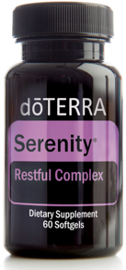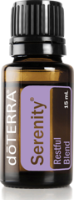

|  |  |
| --- | --- |
| Personal Care Make Over | |
| Over the Counter | **All Natural dōTERRA Product Replacement** |
| * Shampoo & Conditioner | * dōTERRA Salon Essentials® Protecting Shampoo and Smoothing Conditioner |
| * Hair Serum | * dōTERRA Root to Tip Serum |
| * Skin Care | * Veráge Skin Care Collection * Essential Skin Care Collection * Reveal System |
| * Soaps | * Bath bars |
| * Deodorant | * dōTERRA deodorants |
| * Lotions & Body Butter | * Unscented Hand & Body lotion, Essential Oil scented body butter |
| * Body wash | * Essential oil body wash |
| * Body Mist | * Beautiful body mist |
| * Body Repair | * Yarrow|Pom Collection (Beauty inside and out) |
| * Lip Balm | * dōTERRA Essential Oil lip balms |
| * Body Scrubs | * dōTERRA Body scrub |
| * Toothpaste | * dōTERRA Fluoride-free toothpaste |
| * Mouthwash | * dōTERRA On Guard mouthwash |

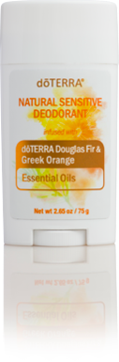

|  |  |
| --- | --- |
| Household Cleaners Make Over | |
| Over the Counter | **All Natural dōTERRA Product Replacement** |
| * Laundry Detergent | * dōTERRA On Guard Laundry Detergent |
| * Anti-bacterial handwash | * dōTERRA On Guard Foaming Handwash |
| * All Purpose Cleaner | * dōTERRA On Guard Cleaning Concentrate |
| * Glass Cleaner | * Water, Vinegar, Citrus Oils |
| * Room deodorizer | * Diffuser and your favorite essential oils |
| * Cleaning Scrub | * Baking soda, vinegar, essential oils |

Makes 12 spray bottles $1.20 each

64 loads of laundry 42 cents per load

All natural

No Triclosan

Up to 14 hours

Up to 10 hours

Up to 12 hours

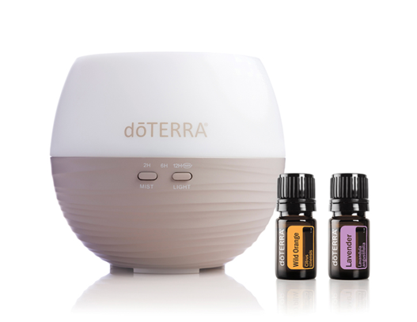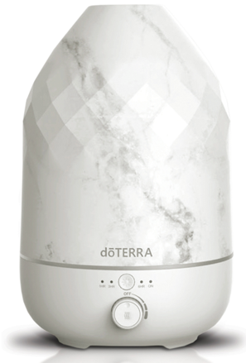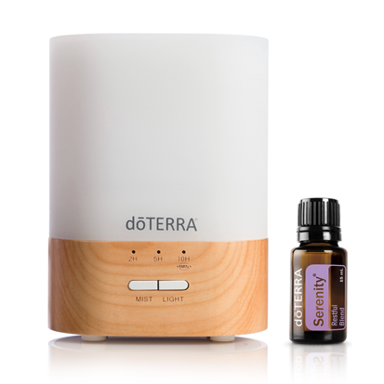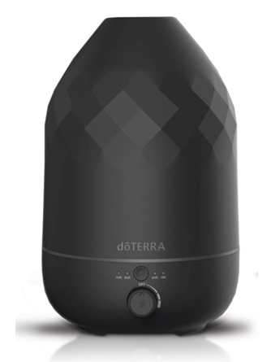

* Oil holders/bags
* Roller Bottles
* Kids product and Essential oil collections
* Reference Guides
* Classes/Education
* Support
* Personalized Wellness Program (option: with bioscanner)

Permanent healing happens when we heal at all levels. Learn how to heal the mind, body and spirit in the Energy Balancing with Faith Course.

<https://jadebalden.com/enroll/>

**About the Energy Balancing Course**

* 7 weeks of lessons
* You have 9 weeks to finish
* Watch Videos & do Quizzes
* FREE Manual & Reference guide for download
* FREE Workbook for download

**Who This Course Is For?**

* Spiritually mature individuals who want to serve God and develop faith
* Feel ready to permanently heal and change
* Open and willing to be taught and coached towards more divine happiness
* Committed to achieve and finish the course
* Those who want to serve others. To fulfill your life’s purpose more fully.

<https://jadebalden.com/lifestyle/>

**Natural Wellness Lifestyle Course**

* Learn how to use essential oils confidently
* Get skills to take care of common health concerns
* 7 weeks of lessons
* You have 9 weeks to finish
* Watch Videos & do Quizzes